Universidad de San Carlos de Guatemala.

Centro Universitario de Occidente.

División de Ciencias de la Ingeniería.

Lenguajes Formales y de Programación.

Sección “A”.

Ing. Oliver Sierra Pac.

“PRÁCTICA I”

Diego José Maldonado Monterroso.

Carné: 201931811.

Quetzaltenango, Guatemala.

05 de octubre de 2021.

**DEFINICIÓN DE EXPRESIONES REGULARES**

**Identificador.**

( [a-z] | [A-Z] )+( ( [A-Z] | [a-z] ) | ( [0-9] ) )*

Por conveniencia:

Letra “L” = [A-Z] ó [a-z].

Digito “D” = [0-9].

Expresión regular: L+( L|D )*

**Número.**

[0-9]+

Por conveniencia:

Digito “D”: [0-9].

Expresión Regular: D+

**Decimal.**

[0-9]+[.][0-9]+

Por conveniencia:

Digito “D”: [0-9].

Expresión Regular: D+[.]D+

**Puntuación.**

Expresión Regular: ( [:] | [;] | [,] | [.] )+

**Operador.**

Expresión Regular: ( [+] | [-] | [*] | [/] | [%] )+

**Signo Agrupación.**

Expresión Regular: ( [(] | [)] | [{] | [}] | [[] | []] )+

**AFD EXPRESIONES REGULARES**

**CREACION AFD IDENTIFICADOR**

Expresión regular: L+( L|D )*

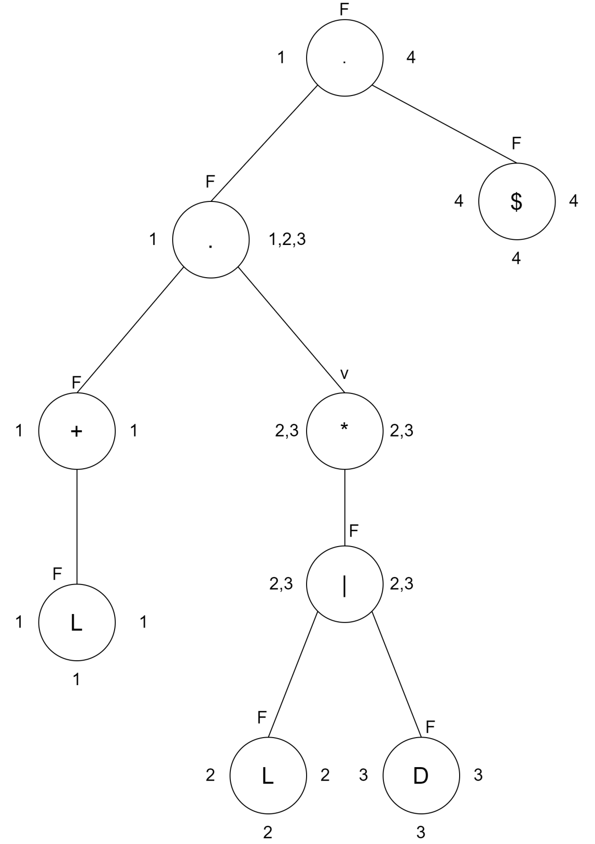

**Tabla Siguientes:**

|  |  |  |
| --- | --- | --- |
| No. | Σ | Siguiente (No.) |
| 1 | L | 1,2,3,4 |
| 2 | L | 2,3,4 |
| 3 | D | 2,3,4 |
| 4 | $ | - |

S0 = {1}

Siguiente(1) = {1,2,3,4} -> S1

δ(S0,L) = S1

Siguiente(2) = {2,3,4} -> S2

δ(S1,L) = S2

Siguiente(3) = {2,3,4} -> S2

δ(S1,D) = S2

**Tabla de Transiciones:**

|  |  |  |
| --- | --- | --- |
| Q\ Σ | L | D |
| S0 | S1 | - |
| S1 | S2 | S2 |
| S2 | S2 | S2 |

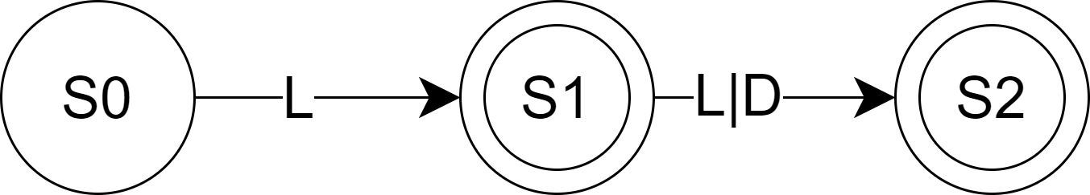**Definición Formal AFD Identificador.**

1. Q = {S0, S1, S2}
2. S0
3. Σ = {L, D}
4. F ={S1, S2}
5. Función de Transición:

δ(S0,L) = S1

δ(S1,L) = S2

δ(S1,D) = S2

δ(S2,L) = S2

δ(S2,D) = S2

**CREACIÓN AFD NÚMERO**

Expresión Regular: D+

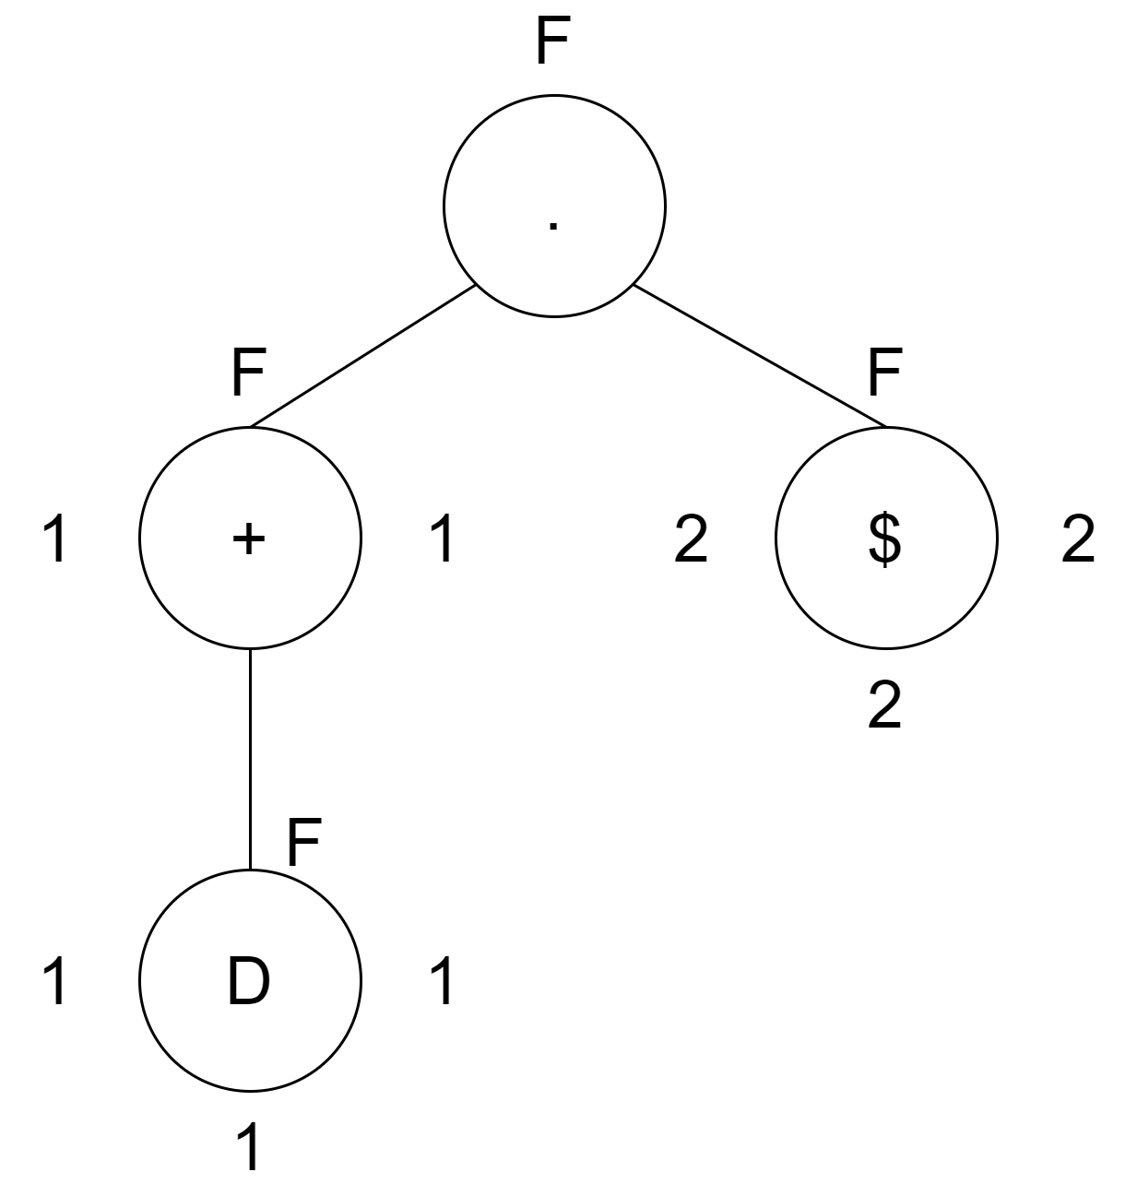

2

1

**Tabla Siguientes:**

|  |  |  |
| --- | --- | --- |
| No. | Σ | Siguiente (No.) |
| 1 | D | 1,2 |
| 2 | $ | - |

S0 = {1}

Siguiente(1) = {1,2} -> S1

δ(S0,D) = S1

**Tabla de Transiciones:**

|  |  |
| --- | --- |
| Q\ Σ | D |
| S0 | S1 |
| S1 | S1 |

**Definición Formal AFD Número.**

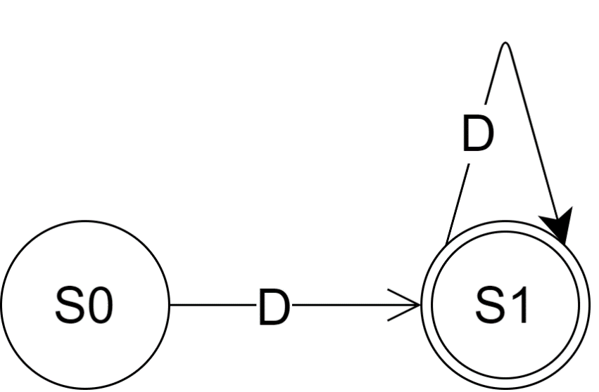

1. Q = {S0, S1}
2. S0
3. Σ = { D}
4. F ={S1}
5. Función de Transición:

δ(S0,D) = S1

δ(S1,D) = S1

**CREACIÓN AFD DECIMAL**

Expresión Regular: D+[.]D+

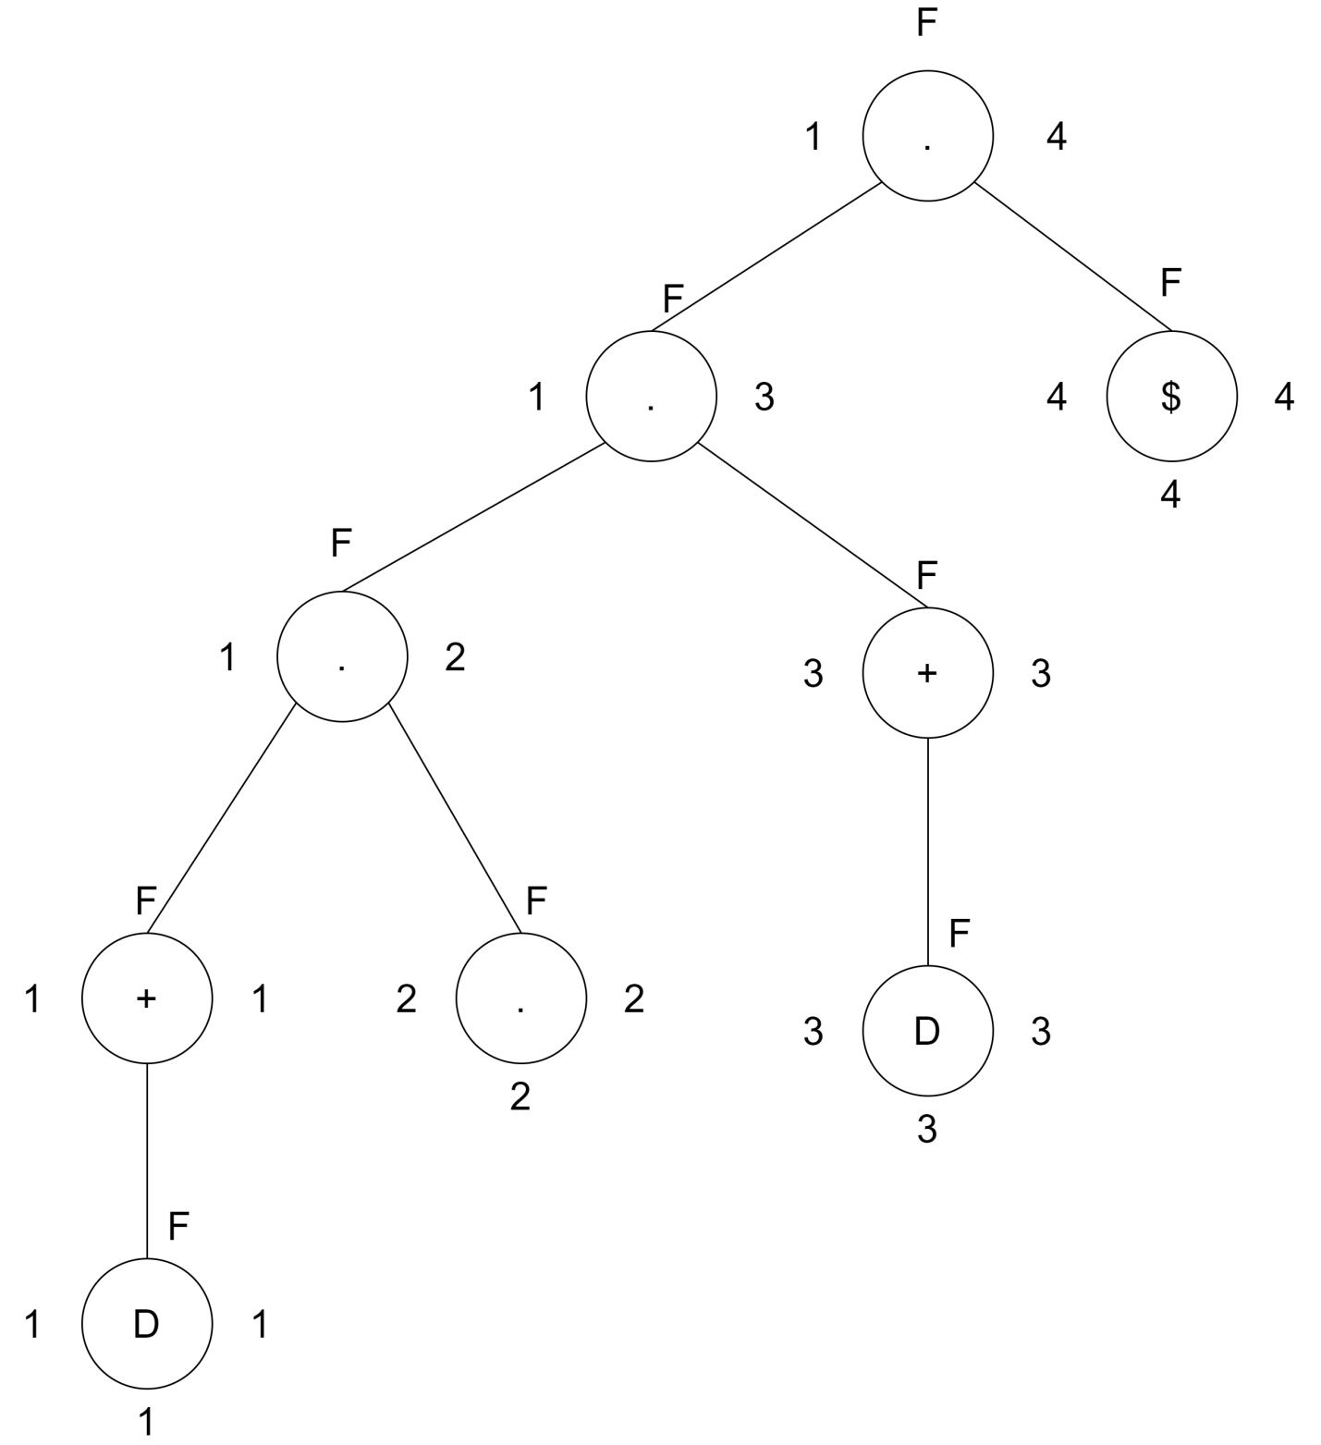

**Tabla Siguientes:**

|  |  |  |
| --- | --- | --- |
| No. | Σ | Siguiente (No.) |
| 1 | D | 1,2 |
| 2 | . | 3 |
| 3 | D | 3,4 |
| 4 | $ | - |

S0 = {1}

Siguiente(1) = {1,2} -> S1

δ(S0,D) = S1

Siguiente(2) = {3} -> S2

δ(S1,.) = S2

Siguiente(3) = {3,4} -> S3

δ(S2,D) = S3

**Tabla de Transiciones:**

|  |  |  |
| --- | --- | --- |
| Q\ Σ | D | . |
| S0 | S1 | - |
| S1 | - | S2 |
| S2 | S3 | - |
| S3 | S3 | S3 |

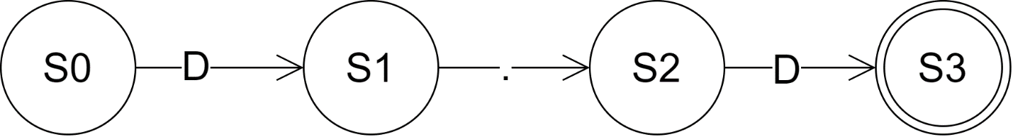**Definición Formal AFD Decimal.**

1. Q = {S0, S1, S2, S3}
2. S0
3. Σ = { D, .}
4. F ={S3}
5. Función de Transición:

δ(S0,D) = S1

δ(S1,.) = S2

δ(S2,D) = S3

δ(S3,D) = S3

**CREACIÓN AFD SIGNO PUNTUACIÓN**

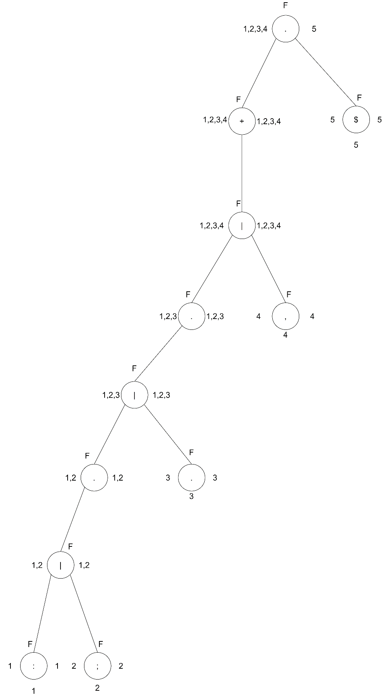 Expresión Regular: ( [:] | [;] | [,] | [.] )+

**Tabla Siguientes:**

|  |  |  |
| --- | --- | --- |
| No. | Σ | Siguiente (No.) |
| 1 | : | 1,2,3,4,5 |
| 2 | ; | 1,2,3,4,5 |
| 3 | . | 1,2,3,4,5 |
| 4 | , | 1,2,3,4,5 |
| 5 | $ | - |

S0 = {1}

Siguiente(1) = {1,2,3,4,5} -> S1

δ(S0, :) = S1

Siguiente(2) = {1,2,3,4,5} -> S1

δ(S0, ;) = S1

Siguiente(3) = {1,2,3,4,5} -> S1

δ(S0, .) = S1

Siguiente(4) = {1,2,3,4,5} -> S1

δ(S0, ,) = S1

**Tabla de Transiciones:**

|  |  |  |  |  |
| --- | --- | --- | --- | --- |
| Q\ Σ | : | ; | . | , |
| S0 | S1 | S1 | S1 | S1 |
| S1 | S1 | S1 | S1 | S1 |

**Definición Formal AFD Puntuación.**

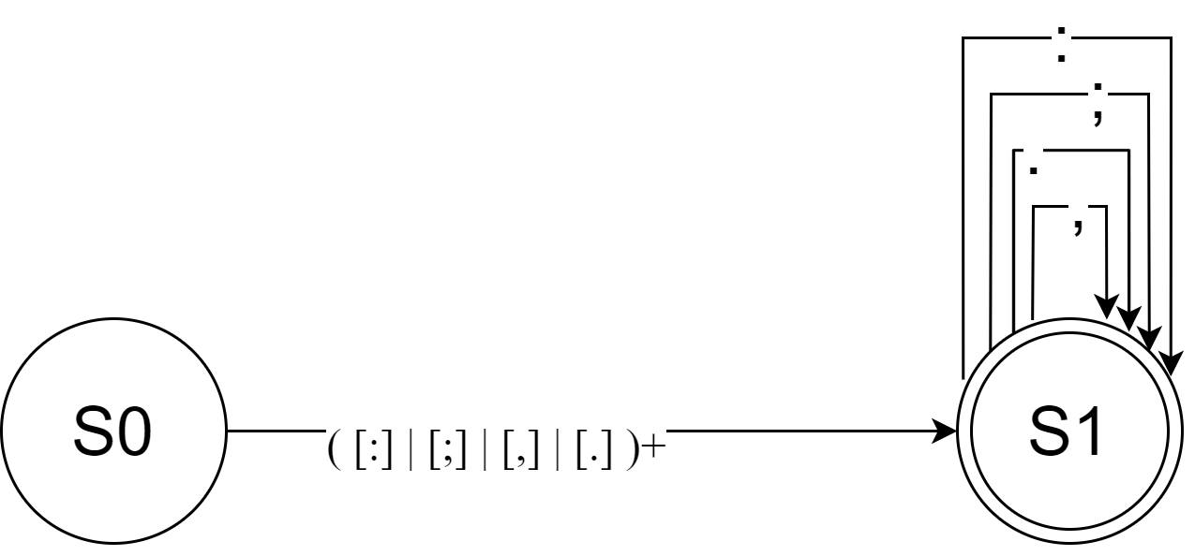

1. Q = {S0, S1}
2. S0
3. Σ = { **:** , **;** , **,** , **.**}
4. F ={S1}
5. Función de Transición:

δ(S0, :) = S1 δ(S1, :) = S1

δ(S0, ;) = S1 δ(S1, ;) = S1

δ(S0, .) = S1 δ(S1, .) = S1

δ(S0, ,) = S1 δ(S1, ,) = S1

**CREACIÓN AFD OPERADOR**

Expresión Regular: ( [+] | [-] | [*] | [/] | [%] )+

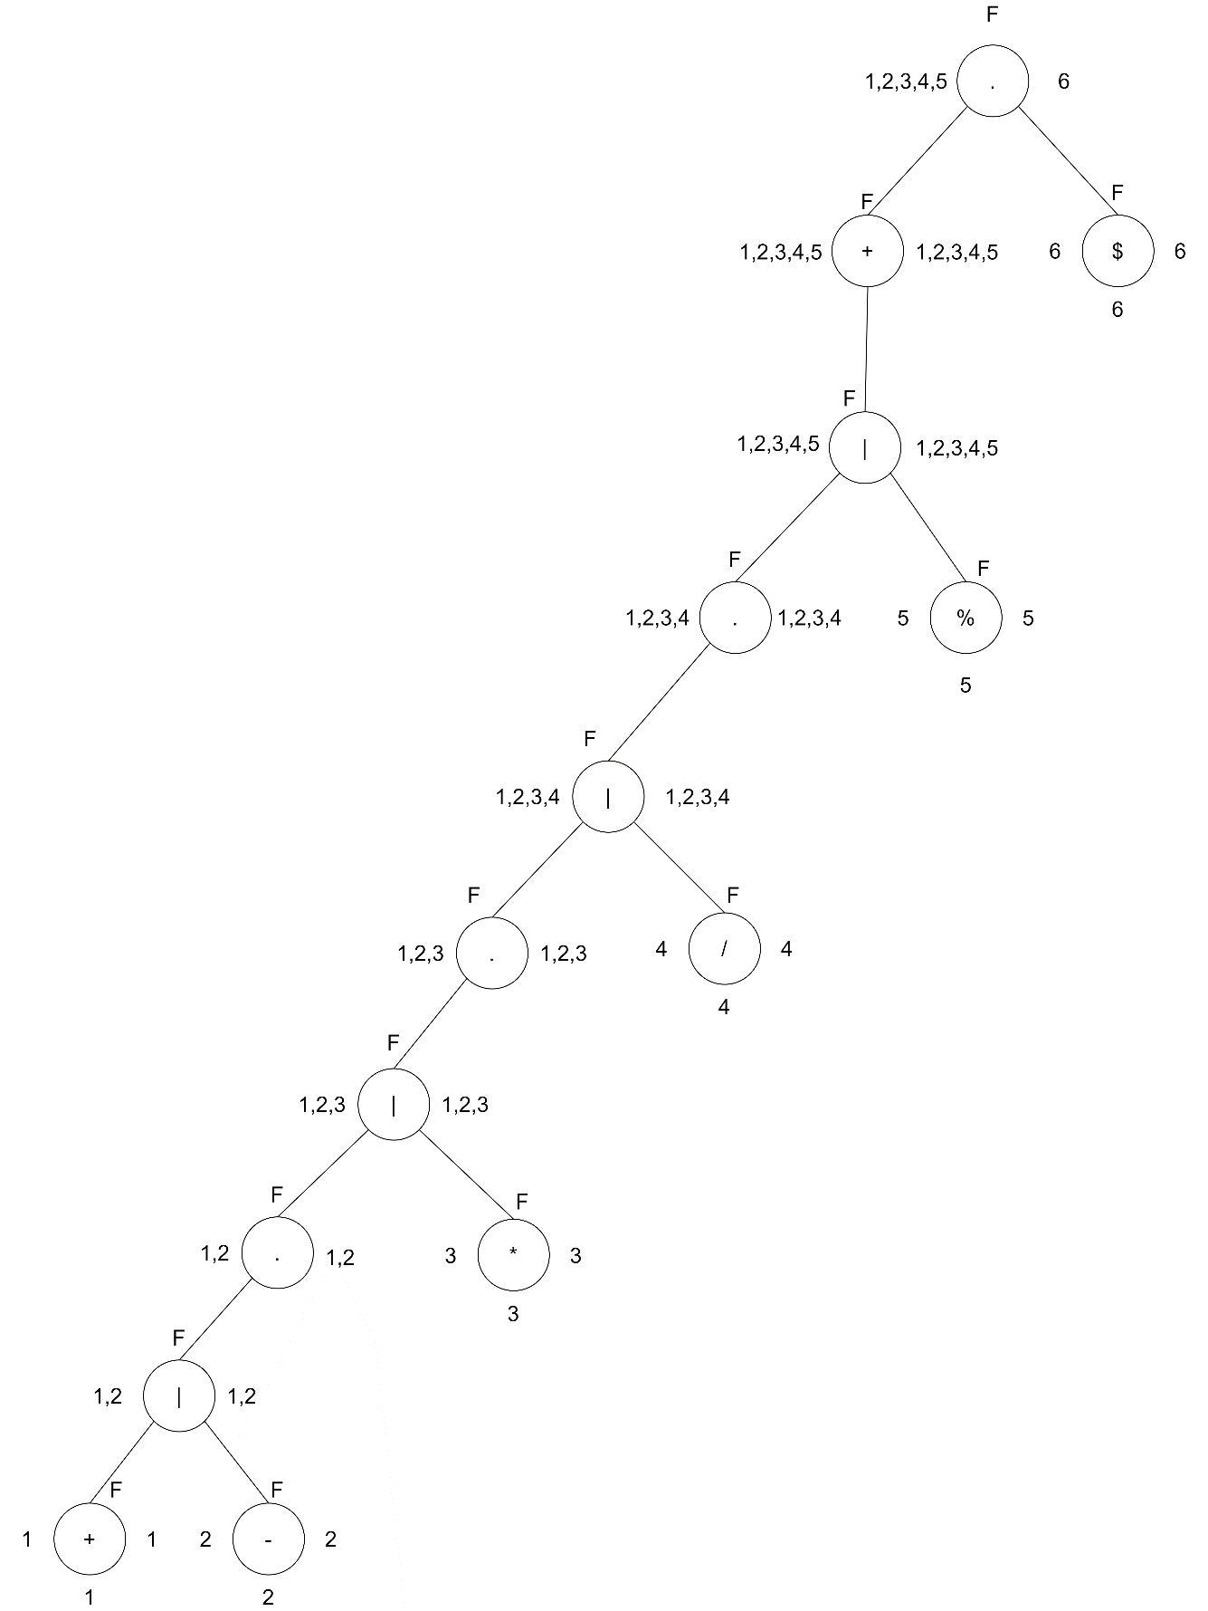

**Tabla Siguientes:**

|  |  |  |
| --- | --- | --- |
| No. | Σ | Siguiente (No.) |
| 1 | + | 1,2,3,4,5,6 |
| 2 | - | 1,2,3,4,5,6 |
| 3 | * | 1,2,3,4,5,6 |
| 4 | / | 1,2,3,4,5,6 |
| 5 | % | 1,2,3,4,5,6 |
| 6 | $ | - |

S0 = {1}

Siguiente(1) = {1,2,3,4,5,6} -> S1

δ(S0, +) = S1

Siguiente(2) = {1,2,3,4,5,6} -> S1

δ(S0, -) = S1

Siguiente(3) = {1,2,3,4,5,6} -> S1

δ(S0, *) = S1

Siguiente(4) = {1,2,3,4,5,6} -> S1

δ(S0, /) = S1

Siguiente(5) = {1,2,3,4,5,6} -> S1

δ(S0, %) = S1

**Tabla de Transiciones:**

|  |  |  |  |  |  |
| --- | --- | --- | --- | --- | --- |
| Q\ Σ | + | - | * | / | % |
| S0 | S1 | S1 | S1 | S1 | S1 |
| S1 | S1 | S1 | S1 | S1 | S1 |

**Definición Formal AFD Operador.**

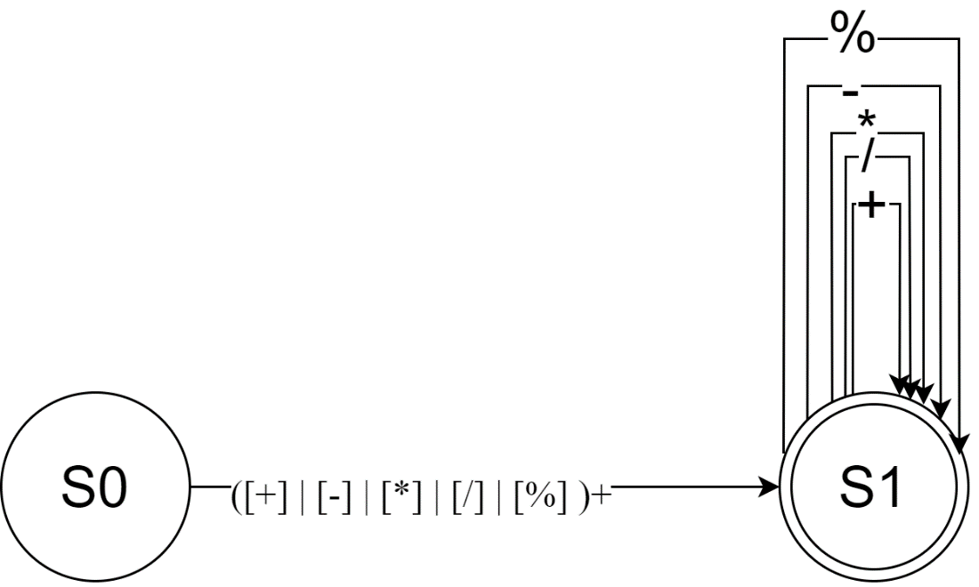

1. Q = {S0, S1}
2. S0
3. Σ = { **+** , **-** , **\*** , **/ , %**}
4. F ={S1}
5. Función de Transición:

δ(S0, +) = S1 δ(S1, +) = S1

δ(S0, -) = S1 δ(S1, -) = S1

δ(S0, *) = S1 δ(S1, *) = S1

δ(S0, /) = S1 δ(S1, /) = S1

δ(S0, %) = S1 δ(S1, %) = S1

**CREACIÓN AFD SIGNO AGRUPACIÓN**

Expresión Regular: ( [(] | [)] | [{] | [}] | [[] | []] )+

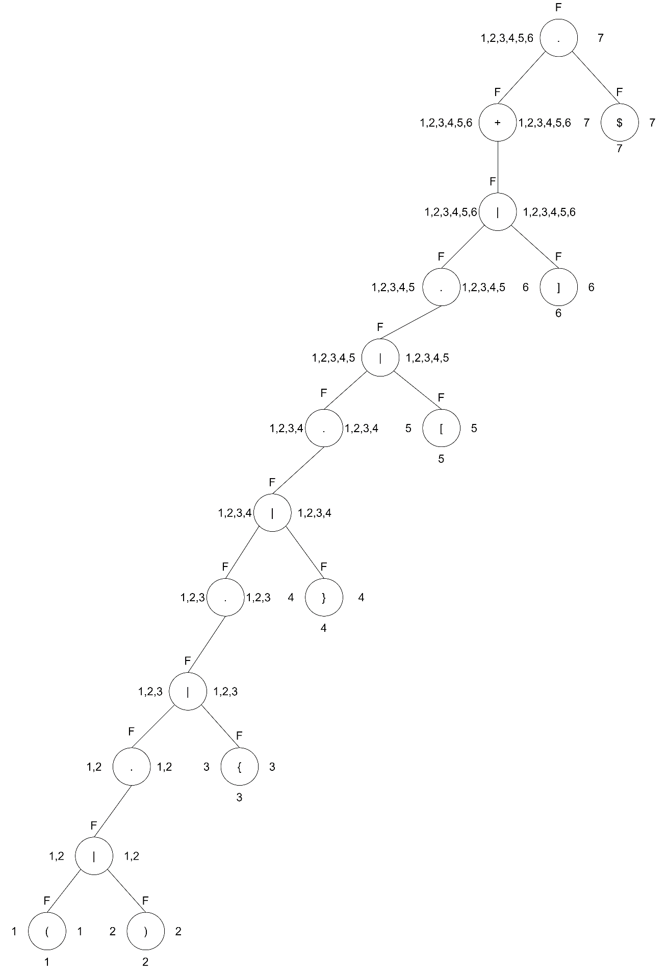

**Tabla Siguientes:**

|  |  |  |
| --- | --- | --- |
| No. | Σ | Siguiente (No.) |
| 1 | ( | 1,2,3,4,5,6,7 |
| 2 | ) | 1,2,3,4,5,6,7 |
| 3 | { | 1,2,3,4,5,6,7 |
| 4 | } | 1,2,3,4,5,6,7 |
| 5 | [ | 1,2,3,4,5,6,7 |
| 6 | ] | 1,2,3,4,5,6,7 |
| 7 | $ | - |

S0 = {1}

Siguiente(1) = {1,2,3,4,5,6,7} -> S1

δ(S0, ( ) = S1

Siguiente(2) = {1,2,3,4,5,6,7} -> S1

δ(S0, ) ) = S1

Siguiente(3) = {1,2,3,4,5,6,7} -> S1

δ(S0, { ) = S1

Siguiente(4) = {1,2,3,4,5,6,7} -> S1

δ(S0, } ) = S1

Siguiente(5) = {1,2,3,4,5,6,7} -> S1

δ(S0, [ ) = S1

Siguiente(6) = {1,2,3,4,5,6,7} -> S1

δ(S0, ] ) = S1

**Tabla de Transiciones:**

|  |  |  |  |  |  |  |
| --- | --- | --- | --- | --- | --- | --- |
| Q\ Σ | ( | ) | { | } | [ | ] |
| S0 | S1 | S1 | S1 | S1 | S1 | S1 |
| S1 | S1 | S1 | S1 | S1 | S1 | S1 |

**Definición Formal AFD Signo de Agrupación.**

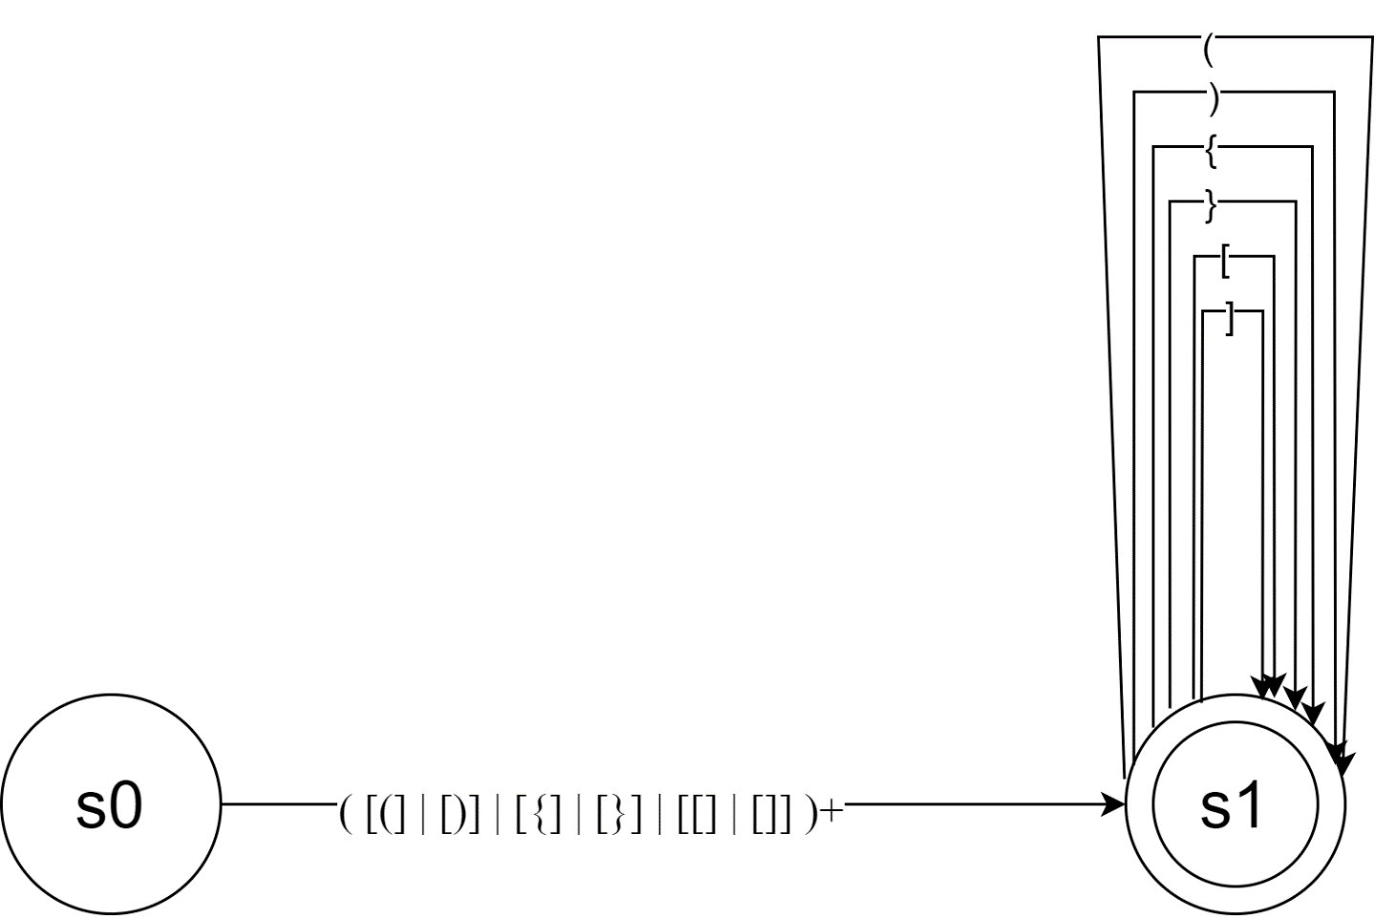

1. Q = {S0, S1}
2. S0
3. Σ = { **(** , **)** , **{** , **} , [ , ]**}
4. F ={S1}
5. Función de Transición:

δ(S0, ( ) = S1 δ(S1, ( ) = S1

δ(S0, ) ) = S1 δ(S1, ) ) = S1

δ(S0, { ) = S1 δ(S1, { ) = S1

δ(S0, } ) = S1 δ(S1, } ) = S1

δ(S0, [ ) = S1 δ(S1, [ ) = S1

δ(S0, ] ) = S1 δ(S1, ] ) = S1

**CONVENIOS PARA CREACIÓN AFD FINAL**

Por conveniencia se hacen los siguientes arreglos para simplificar un poco el Autómata:

Letra: L = [A-Z] o [a-z].

Digito: D = [0-9].

Puntuación: P = [: | ; | , | .].

Operador: O = [+ | - | * | / | %].

Agrupación: A = [( | ) | { | } | [ | ] ].

Expresiones Regulares:

Identificador: L+(L | D)*

Número: D+

Decimal: D+[.]D+

Signo Puntuación: P+

Operador: O+

Agrupación: A+

**CREACIÓN AFD FINAL**

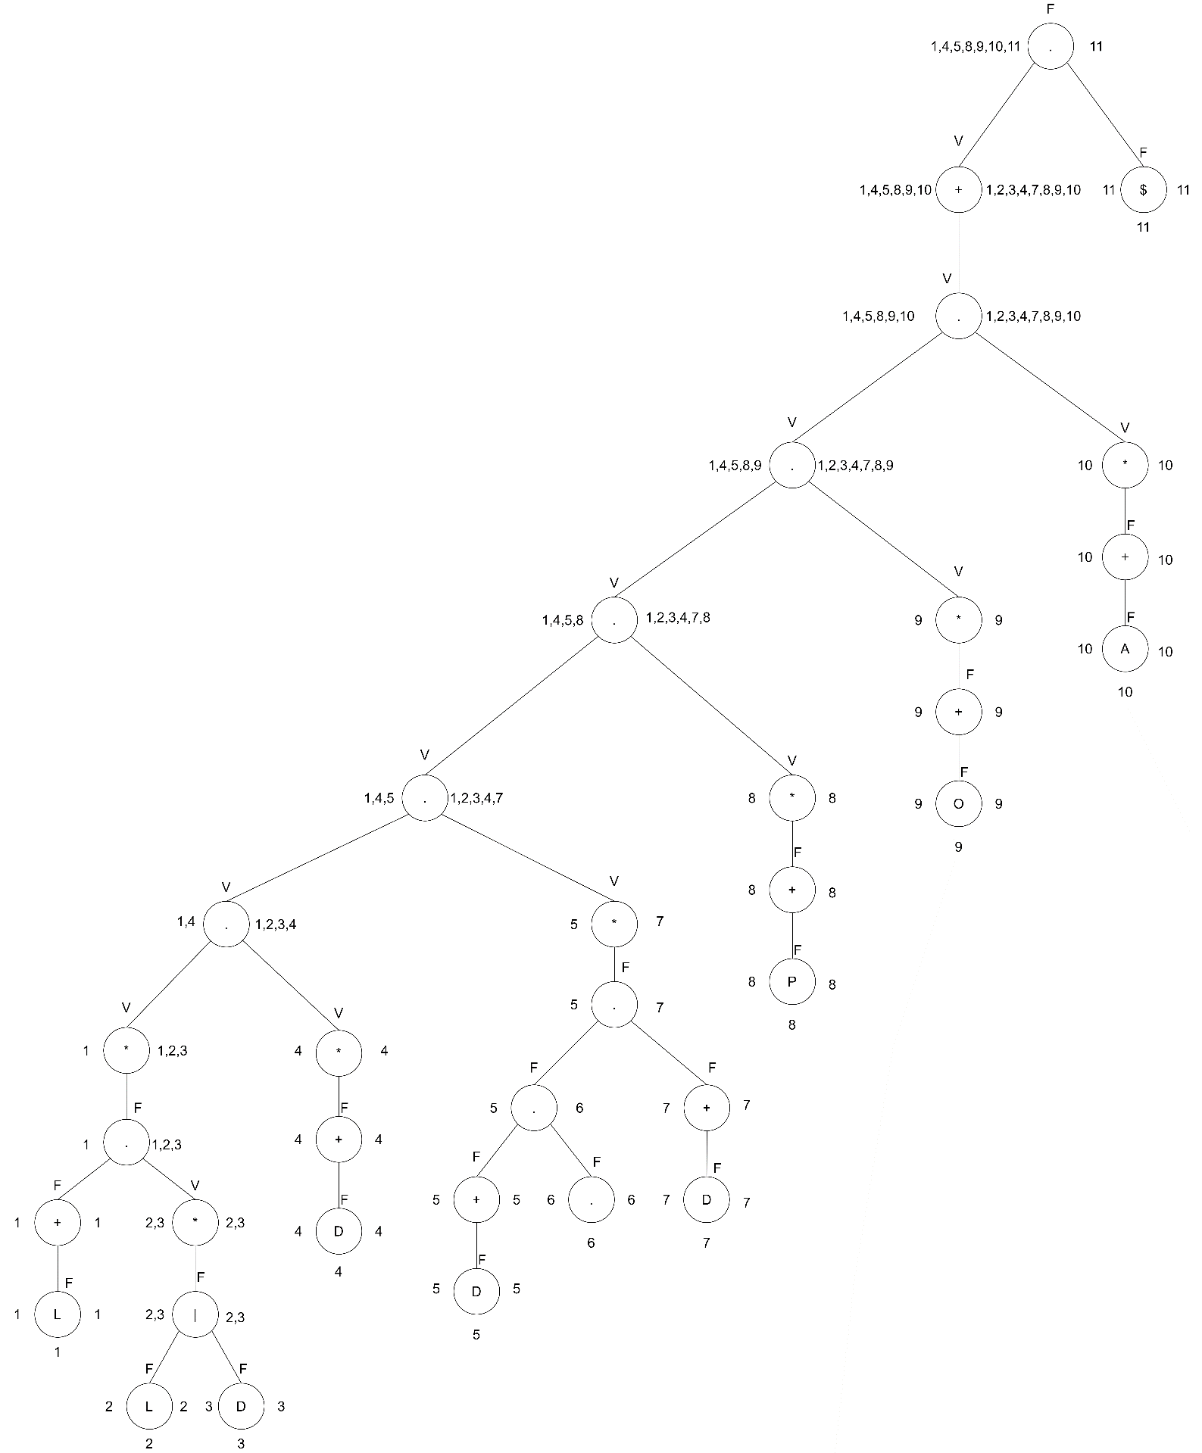 **(** ( L+(L|D)* )* ( D+ )* ( D+[.]D+ )* ( P+ )* ( O+ )* ( A+ )* )+

**Tabla Siguientes:**

|  |  |  |
| --- | --- | --- |
| No. | Σ | Siguiente (No.) |
| 1 | L | 1,2,3,4,5,8,9,10,11 |
| 2 | L | 2,3,4,5,8,9,10,11 |
| 3 | D | 2,3,4,5,8,9,10,11 |
| 4 | D | 4,5,8,9,10,11 |
| 5 | D | 5,6 |
| 6 | . | 6,7 |
| 7 | D | 7,8,9,10,11 |
| 8 | P | 8,9,10,11 |
| 9 | O | 9,10,11 |
| 10 | A | 10,11 |
| 11 | $ | - |

S0 = {1}

Siguiente(1) = {1,2,3,4,5,8,9,10,11} -> S1

δ(S0, L ) = S1

Siguiente(2) = {2,3,4,5,8,9,10,11} -> S2

δ(S1,L) = S2

Siguiente(3) = {2,3,4,5,8,9,10,11} -> S2

δ(S1,D) = S2

Siguiente(4) = {4,5,8,9,10,11} -> S3

δ(S0,D) = S3

Siguiente(5) = {5,6} -> S4

δ(S0, D ) = S4

Siguiente(6) = {6,7} -> S5

δ(S4, . ) = S5

Siguiente(7) = {7,8,9,10,11} -> S6

δ(S5, D ) = S6

Siguiente(8) = {8,9,10,11} -> S7

δ(S0, P ) = S7

Siguiente(9) = {9,10,11} -> S8

δ(S0, O ) = S8

Siguiente(10) = {10,11} -> S9

δ(S0, A ) = S9

**Tabla de Transiciones:**

|  |  |  |  |  |  |  |
| --- | --- | --- | --- | --- | --- | --- |
| Q\ Σ | L | D | . | P | O | A |
| S0 | S1 | S3, S4 | - | S7 | S8 | S9 |
| S1 | S2 | S2 | - | - | - | - |
| S2 | S2 | S2 | - | - | - | - |
| S3 | - | S3 | - | - | - | - |
| S4 | - | - | S5 | - | - | - |
| S5 | - | S6 | - | - | - | - |
| S6 | - | S6 | - | - | - | - |
| S7 | - | - | - | S7 | - | - |
| S8 | - | - | - | - | S8 | - |
| S9 | - | - | - | - | - | S9 |

**Definición Formal AFD Final.**

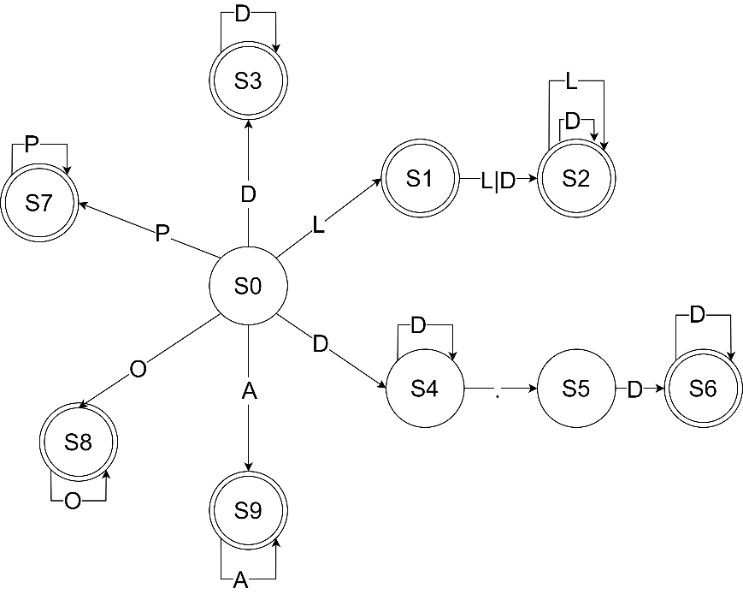

1. Q = {S0, S1, S2, S3, S4, S5, S6, S7, S8, S9}
2. S0
3. Σ = { **L, D, . , P, O, A** }
4. F ={S1, S2, S3, S6, S7, S8, S9}
5. Función de Transición:

δ(S0, L) = S1 δ(S1, D ) = S2 δ(S1, L ) = S2

δ(S2, L ) = S2 δ(S2, D ) = S2 δ(S0, D ) = S3

δ(S3, D ) = S3 δ(S0, D ) = S4

δ(S4, D ) = S4 δ(S4, . ) = S5

δ(S5, D ) = S6 δ(S6, D ) = S6

δ(S0, P ) = S7 δ(S7, P ) = S7

δ(S0, O ) = S8 δ(S8, O ) = S8

δ(S0, A ) = S9 δ(S9, A ) = S9

**OPTIMIZACIÓN AFD FINAL**

Agrupación Estados de Aceptación.

|  |  |  |
| --- | --- | --- |
| Estados No Aceptación | | |
| S0 | S4 | S5 |

|  |  |  |  |  |  |  |  |
| --- | --- | --- | --- | --- | --- | --- | --- |
| Estados Aceptación | | | | | | | |
| S1 | S2 | S3 | S6 | S7 | S8 | S9 |

Función Transición.

|  |  |  |  |  |  |
| --- | --- | --- | --- | --- | --- |
| δ(S0, L)=S1 | δ(S1, D )=S2 | δ(S2, D )=S2 | δ(S3, D ) =S3 | δ(S4, D ) =S4 | δ(S5, D )=S6 |
| δ(S0, D )=S3 | δ(S1, L )=S2 | δ(S2, L )=S2 |  | δ(S4, . )=S5 |  |
| δ(S0, D )=S4 |  |  |  |  |  |
| δ(S0, P )=S7 |  |  |  |  |  |
| δ(S0, O )=S8 |  | δ(S6, D )=S6 | δ(S7, P )=S7 | δ(S8, O )=S8 | δ(S9, A )=S9 |
| δ(S0, A )=S9 |  |  |  |  |  |

|  |  |  |  |  |  |  |
| --- | --- | --- | --- | --- | --- | --- |
| Estados Aceptación | | | | | | |
| S1 | S2 | S3 | S6 | S7 | S8 | S9 |

Tabla Estados.

|  |  |  |
| --- | --- | --- |
| Estados No Aceptación | | |
| S0 | S4 | S5 |

L S1 - - S2 S2 - - - - -

D S3 S4 S6 S2 S2 S3 S6 - - -

. - S5 - - - - - - - -

P S7 - - - - - - S7 - -

O S8 - - - - - - - S8 -

A S9 - - - - - - - - S9

**Misma transiciones δ(S3, D ) =S3 y δ(S4, D ) =S4**

Nueva Tabla de Transiciones:

|  |  |  |  |  |  |
| --- | --- | --- | --- | --- | --- |
| δ(S0, L)=S1 | δ(S1, D )=S2 | δ(S2, D )=S2 | δ(S3, D ) =S3 | δ(S4, D )=S5 | δ(S5, D )=S5 |
| δ(S0, D )=S3 | δ(S1, L )=S2 | δ(S2, L )=S2 | δ(S3, . )=S4 |  |  |
| δ(S0, D )=S4 |  |  |  |  |  |
| δ(S0, P )=S7 |  |  |  |  |  |
| δ(S0, O )=S8 |  |  | δ(S6, P )=S6 | δ(S7, O )=S7 | δ(S8, A )=S8 |
| δ(S0, A )=S9 |  |  |  |  |  |

**Definición Formal AFD Final.**

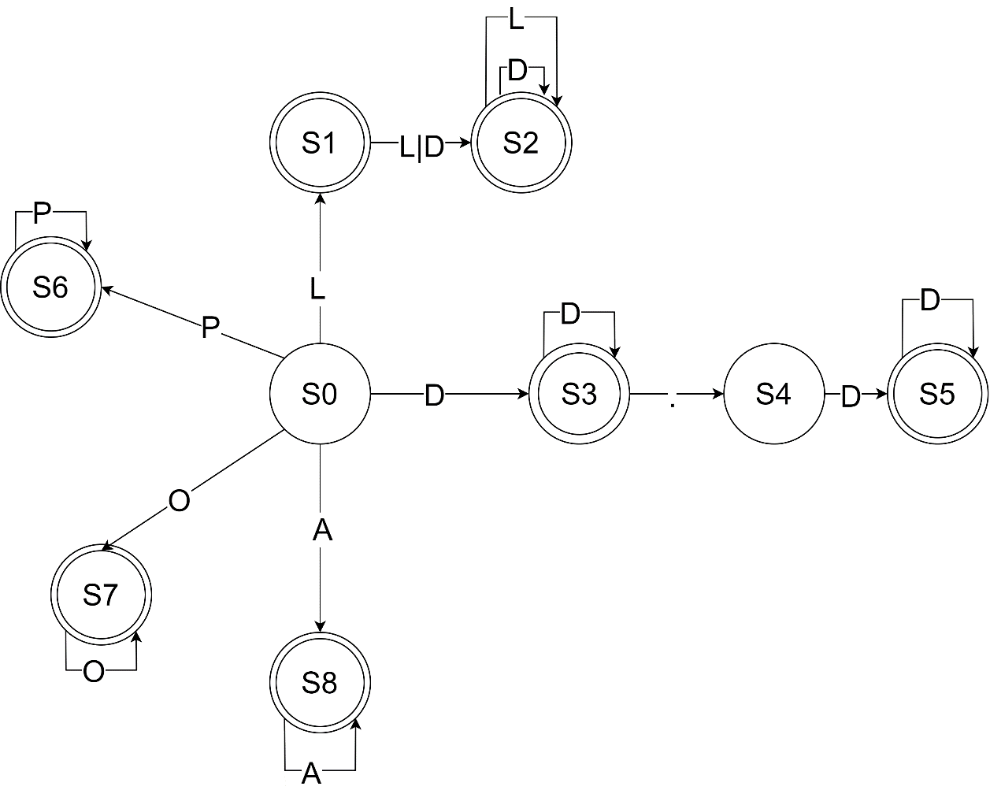

1. Q = {S0, S1, S2, S3, S4, S5, S6, S7, S8 }
2. S0
3. Σ = { **L, D, . , P, O, A** }
4. F ={S1, S2, S3, S5, S6, S7, S8}
5. Función de Transición:

|  |  |  |  |  |  |
| --- | --- | --- | --- | --- | --- |
| δ(S0, L)=S1 | δ(S1, D )=S2 | δ(S2, D )=S2 | δ(S3, D ) =S3 | δ(S4, D )=S5 | δ(S5, D )=S5 |
| δ(S0, D )=S3 | δ(S1, L )=S2 | δ(S2, L )=S2 | δ(S3, . )=S4 |  |  |
| δ(S0, D )=S4 |  |  |  |  |  |
| δ(S0, P )=S7 |  |  |  |  |  |
| δ(S0, O )=S8 |  |  | δ(S6, P )=S6 | δ(S7, O )=S7 | δ(S8, A )=S8 |
| δ(S0, A )=S9 |  |  |  |  |  |